Transfer Document Contra-Hacker

# Introduction

This is a transfer document for the project Contra-Hacker. Contra-Hacker is a game made for educational purposes, teaching about the Cyber-Security awareness topics of social engineering and phishing. In the game, you are an administrative worker, tasked with answering mails for the company. During this, you must watch out for any potential phishing mails and report them, choosing the appropriate red flags. The mails you must answer can be randomly generated to make sure the experience is different each time.

# Documentation guide

The documentation is mostly contained in the GDD 1-pager and GDD 10-pager, which can be found in the folder phase 2-game design. For a more detailed explanation on the research, refer to the reading guide.

# Installation guide

The game project can be found in the current folder. The folder name is Contra-Hacker. You can open this folder with Unity Hub to edit and add new mails. The main scene is MainDeskScene.

The game build is a WebGL build, which is contained in the aforementioned folder (Contra-Hacker > Build.) To host the game, you must have a webserver hosted. Drag the files contained in the folder to the webserver’s folder.

# Guide on adding mails and days

## Mails

While in the Unity editor, you can add your own mails and days. In the top tab, click Assets>Create>Mail Object.

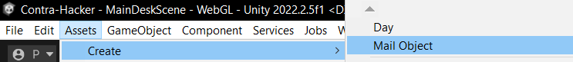

From there, you can start inputting the mail fields in the inspector.

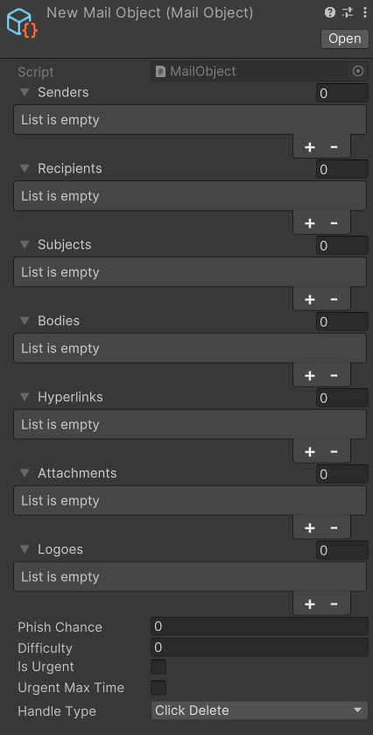

In here, there are various fields detailing what the mail can look like:

1. Senders details the mail address that sent the mail.
2. Recipients details the mail address that received the mail. The player has three mail addresses linked:   
   - business@muisbakkers.nl (company business mail, usually used by customers.)

-Jan.de.groot@gmail.com (private mail)

-Jan@muisbakkers.nl (company account, usually for internal business.)

1. Subjects details the mail subject(s) displayed in the mail and the mail side previews.
2. Bodies details the text that can be in the main body of the mail. Give context as how to handle the mail in here.
3. Hyperlinks detail any links attached to the mail. If left empty, there will be no link in the mail.
4. Attachments, when filled in, adds a file to the mail. The input is the file name.
5. Logoes take an image as input and add a logo image to the bottom of the mail. This is optional.
6. Phish chance is the chance a mail will be phishing. Set this to 0 if you want a normal mail, or to 1 if you want a phishing mail.
7. Is Urgent and Urgent Max Time can be ignored.
8. Handle type is how the player should successfully complete the mail. You can:

-Forward the mail to another person, if the mail suggests it is for someone else.

-Click the attached link

-Click the attached attachment

-Delete the mail (use only for spam or mails that do not require action.)

Phishing mails should have two different values per field; one where it’s not a red flag and one where it is. The code will then randomize and pick an amount of red flags equal to the difficulty. If the body is a red flag, the subject will always be one too.

Once you have created a mail in the editor, you must still drag it into the pool of mails available throughout the day. On the game object GlobalScripts there is an object named MailsGetter.

On there is a script where you can drag the object you made into the “All Mail Objects” list.

This should add it to the available pool of mails.

If you at any point get an object reference error, you should check if each field of the mails is filled in, and if you have two fields per part for phishing mails.

## Days

To add a day, you can create one in the same way as a mail.

The variables work as follows:

1. Current day requires no filling in.
2. Time requires no filling in.
3. Day Length is the duration of the day, in seconds. This is usually 420; this makes the day last until 16:00
4. Message Spread is a list that details when a random mail will be sent. You can put in a point in time here. For example:

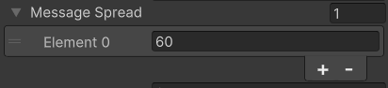

This sends a randomized mail when 60 seconds have passed.

1. Difficulty is obsolete.
2. Guaranteed Mails details certain mails that are always sent at a specified time. For example:

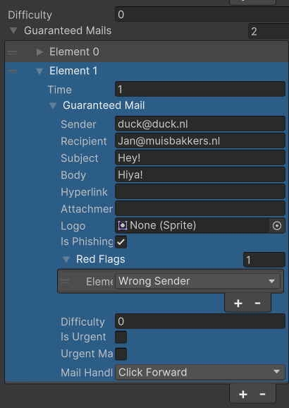

This sends a mail at the start of the day, from the mailer duck@duck.nl, to your work account, subject Hey! and body Hiya!. This is a phishing mail with the red flag of having a suspicious sender. The intent of the mail is then to make the player forward it.

Days must be dragged into the DayManager.

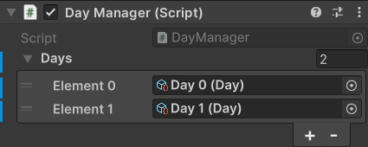

When adding a day, be sure to also add a news entry for that day. You can use the previous news prefabs (day0news and day1news) as a template. Duplicate one and then drag it into the daymanager script.

# Code structure

# Suggested features to be added

1. Add sound design as detailed in the GDD. There is currently no music and sounds in the game, and adding it would help with the aesthetics of the game.
2. Once again for aesthetics, add a mechanic with the phone that makes more use of it. Currently it only holds an address list, and adding gameplay to it could give the game the more hectic feeling.
3. There needs to be more after a day has ended. During the target group test, I ran the game by two teachers as well and they noted that they might want a stats screen at the end, showing you what you did wrong or not. Alternatively, there could be a proper lose condition; for example if you get hacked three times you’d have to restart. At least some way of telling the player how well they did overall. The shop could also be a good inclusion.
4. More interactivity with the trinkets. During my latest test I found that the player was waiting for new mails or the day to end. Therefore, it would be useful to add more to the trinkets in order to give the player something to do.
5. Mail storylines: To improve consistency throughout mails, there is an idea to group certain mails together and only send the next one if the last one has been answered.
6. Hint system: In an earlier test, some testers were unsure about some of the actions they were going to take. The idea is to add an antivirus scan, which would then tell you if a certain part of a mail is safe or not, but would take some time to use.
7. Improved visuals.
8. More mails and days must be added.